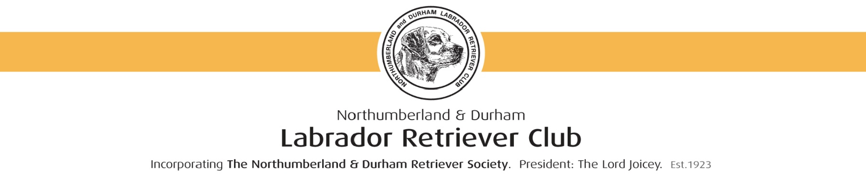
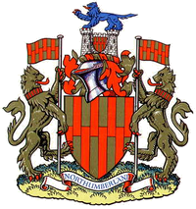
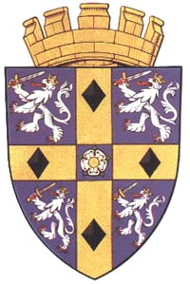
Northumberland and Durham
Labrador Retriever Club
Incorporating The Northumberland and Durham Retriever Society. Est. 1923

MEMBERSHIP APPLICATION FORM

Northumberland and Durham Labrador Retriever Club (referred to as the “club” or “N&DLRC”), thank you for your interest in our club. Please read the form carefully before completing the application. Steps to apply for membership:
- Please read the ‘important information’
- Complete the form in ink or type
- Include your email address for future communications
- NO PAYMENT IS REQUIRED UNTIL YOUR APPLICATION IS ACCEPTED
- Return to our Treasurer/Membership Secretary by post or via email
- On receipt of your fully completed application form your application will be considered at our March General Committee meeting providing you are correctly proposed and seconded.
- After ratification your joining membership fee will be required within 7 days of your welcome email, after which you will be entitled to full member benefits. The Committee retain the right to decline membership and return fees without declaring the reason; during the first year of membership.

This form is editable in the sections needing completion. It can then be printed out and posted or submitted on line.
APPLY ONLINE
By completing the application form and sending the form as an attachment to our club email account ndlabclub@gmail.com

OR SEND POSTAL APPLICATIONS TO:
Mrs Anne Beckley, Treasurer/Membership Secretary
39, Woodford Close, Marske-by-the-Sea, Redcar,
Cleveland TS11 6AJ.
Tel: 01642 477640 email: becklabs@yahoo.com

IMPORTANT INFORMATION - PLEASE READ
RULES: By applying to join the club; you are agreeing to abide by the Rules of the Club, to have read and accepted the clubs Health and Safety Policies and be fully supportive of our Code of Ethics. If breeding, you should aim to produce the type of Labrador Retriever as laid down by the Kennel Club Breed Standard. Please make yourself aware of these as serious breaches could result in your expulsion from the club.

The Rules, Health and Safety Policies, Code of Ethics and Kennel Club Breed Standard are all on the club website: www.ndlabclub.co.uk

ANNUAL MEMBERSHIP: Runs from January 1st until December 31st each year, REGARDLESS OF THE INITIAL JOINING DATE. We do not send reminders and Club information will not be sent when membership fees are unpaid. Fees not paid by 31st March each year will result in the member having to re-apply for membership.
Only fully paid up members on the 31st March will receive full member preferences such as reduced entry fees, health testing costs and preference in field trial draws for that year.

FEES:
£10 Single Membership resident in the UK
£12 Joint Membership resident in the UK
£12 Single Membership NOT resident in the UK
£15 Joint Membership NOT resident in the UK
£5 Junior Membership (under 16’s)

Please make cheques payable to:
NORTHUMBERLAND AND DURHAM LABRADOR RETRIEVER CLUB
* Proposer and Seconder must be fully paid up members of the club. If you are unable to nominate a proposer and seconder, then please attach a note or letter explaining your interest and experience in the breed, plus any other relevant information. Use Black or Blue Ink to complete the form (or type); and print clearly to ensure your details are captured correctly.

IMPORTANT: Please include your email address if you have one as this is our default method of contact.

APPLICATION FORM FOR NEW MEMBERS

I/We wish to apply for membership of the Northumberland and Durham Labrador Retriever Club and authorise my contact details to be stored securely and used by the Club committee and officers for communication relevant to the running of this club in line with UK Data Protection Laws.

(1st Applicant) Title First Name(s)

Surname

(2nd Applicant if joint membership required) Title

First Name(s) Surname

Address

Post Code

Home Tel. No Mobile

Email

KC Affix (if applicable)

*Proposed by (Print Name)

*Seconded by (Print Name)

(Names of Proposer and Seconder will be verified prior to acceptance of membership)

I/We agree to be bound by the rules of the Northumberland and Durham Labrador Retriever Club and fully understand that the committee of the club reserves the right to refuse application for membership, or at any time review membership within the procedures of the constitution.

Signature(s): Date:
WHY JOIN NORTHUMBERLAND AND DURHAM L.R.C?

We pride ourselves on being a friendly and helpful club.
For your annual membership you will receive:
- Information regarding Shows, Working Tests and Field Trials
- Preferential and discounted entry for working events
- Discounted Show Entries
- Help and Advice
- Puppy Register to advertise puppies (conditions apply)
- Representation at Kennel Club, Breed Council, Health Sub Committee and Field Trial Council
- Contact with like-minded people
- Club Website and Facebook Page
- Cups and Trophies – for fully paid up members
- Discount on health testing
- Membership of one of the oldest Labrador Clubs in the UK – established 1923

Please spare a few moments to let us know your interests and tick the Opt in Box to ensure you receive necessary Club Mailings:
Show: I wish to receive mailings from the Club
Working: on Club events and news ONLY.
Both: TICK or MARK ‘X’ HERE
Pet:

Due to new Data protection Laws effective May 2018, you must let us know that you wish to receive information from us. We do not share your information with any third parties apart from Total Club Management and Fosse Data for event entries and some membership payments
..........................................................................................................................................
FOR OFFICE USE ONLY:
Member Passed:
Introduction Letter/email Sent:
Other Action:
On Database:

